PROJECT REPORT
ON

IIPS COUNSELING PORTAL

Master of Technology (Information Technology)

Semester VI

Session Jan – May, 2012

Guided By Submitted By
Mrs. Yasmin Shaikh Ashwini Varma (IT-2K9-07)
Faculty Keshav Patidar (IT-2K9-20)
IIPS, Indore Prathmesh Dubey (IT-2K9-29)

International Institute of Professional Studies
Devi Ahilya Vishwavidyalaya, Indore, M.P.
2012
CERTIFICATE

This is to certify that Ashwini Varma, Keshav Patidar and Prathmesh Dubey of M.Tech (IT) (5¹/₂ yr) VI Semester in the session Jan – May, 2012 have worked on “IIPS Counseling Portal” project thus put in sincere efforts to study the project, collect the materials and successfully complete the project.

Date:
Course Coordinator  (Mrs. Kirti Mathur) | Project Incharge  (Mrs. Yasmin Shaikh)
Internal Examiner | External Examiner

ACKNOWLEDGEMENT
Firstly, I must thank to the almighty GOD. This work is result of inspiration, support, guidance, cooperation and facilities that were extended to us at their best and at the most by Persons at all levels and we are indebted to all of them.

We acknowledge our sincere thanks to those who have contributed significantly to this project. It is a pleasure to extend deep gratitude to Dr. B.K. Tripathi, Director IIPS and Mrs. Kirti Mathur, H.O.D. M.Tech (5¹/₂ years) for their valuable guidance and support. We especially thank our project guide and manager Mrs. Yasmin Shaikh for the helpful solutions and comments enriched by her experience and also for pointing out mistakes and shortcomings from time to time, which will go a long way in completing the project.

We also extend our thanks to our most beloved Parents because of whom we exist and because of whom we are what we are today. We also thank our batch facilitators Mr. Nitin Nagar and Mr. Rahul Singhai for their unending support and belief, which motivated us enormously in completion of this project. Last but not least, we are thankful to all colleagues and friends for their cooperation and encouragement at every stage of this project.

Ashwini Varma  IT-2K9-07  IIPS-DAVV,Indore | Keshav Patidar  IT-2K9-20  IIPS-DAVV,Indore | Prathmesh Dubey  IT-2K9-29  IIPS-DAVV,Indore

TABLE OF CONTENTS
Topic | Page No.
Cover Page  Certificate  Acknowledgement  Table of Contents  List of Figures  List of Tables  - Introduction  - Introduction  - Objectives  - Business Goals and Objectives  - Project Goals and Objectives  - Assumptions  - IIPS Counseling Portal  - Working of Existing System  - Proposed System as Solution  - Project Justification  - Requirement Analysis  - Hardware Requirement  - Software Requirement  - System Analysis  - Information Gathering  - Feasibility Analysis  - Economical Feasibility  - Technical Feasibility  - Behaviour Feasibility  - Risk Analysis  - Technology  - Scope of the Project  - Team Structure  - Gantt Chart  - System Design  - Logical Design  - Data Flow Diagram  - Entity Relationship Diagram  - Physical Design  - Overview  - Physical Database Design Process  - Input Output Design  - User Interface Design  - Testing and Implementation  - Test Plan  - Test Criteria  - Software Quality Assurance  - Screen Shots  - Bibliography  - Books and Manuals  - Web Resources | 1  2  3  4 – 6  7  8  9

LIST OF FIGURES
Figure | Page No.
- Gantt Chart

LIST OF TABLES
Table | Page No.
- Gantt Chart

INTRODUCTION
This project involves creation of counseling portal for International Institute of Professional Studies (IIPS). International Institute of Professional Studies is a autonomous educational institute situated in Indore. It is affiliated to Devi Ahliya Vishwa Vidyalaya (DAVV) University. The most part of the counseling process was earlier done manually and was time consuming, we through our project aims at reducing the manual job to negligible and make the counseling process automated and provide the counseling staff more fast, secure and reliable environment to work upon.
OBJECTIVES
- Business Goals and Objectives :
The business goals and objectives for this project will focus on implementing counseling process that:
- Enhances the ability and effectiveness of staff to perform their jobs.
- Facilitates coordination and information sharing between counseling staff and students in counseling process.
- Less time consuming.
- Provides good interface for counseling staff which make him/her understand the software easily.
- Enhances data security and integrity.
- Facilitates the electronic capture of data.
- Is easy to use.
- Eliminate redundant data entry.
- Stores data electronically for future use.
- Project Goals and Objectives :
- Ensure that counseling staff inputs into the design process.
- Accomplish project business goals and objectives within time parameters.
- Provide security constraints like login page to ensure unauthorized access to data.
- Provide facilities for prevention against some hacking techniques like SQL injection, etc.
- To imbibe the beauty of PHP and MySQL but at the same time makes it user friendly for people unaware of its functionalities.
- To provide dynamic linking between web pages.
- Analyze whether the project is feasible in terms of technology, human resource and cost.
- Develop a plan for project execution.

ASSUMPTIONS
The assumptions for the project are:
- CET result database should be provided in advance.
- The systems on which the software has to be used should have to be P-4 compatible machine with minimum of 512MB of free space in the Hard disk and a 256MB RAM.
- The counseling staff should have some basic knowledge in operating computers.

WORKING OF EXISTING SYSTEM
The current system used for IIPS Counseling consists of mainly manual work. This was basically paper work process. It was a headache to deal with problems like data duplication or data collision.
Limitations of the current system are as follows:
- Since the system is mainly manual, so there is probability for manipulation and error due to carelessness. For example, if a student is unable to fulfill the criteria of 50% in 10th and 12th standard, but due to carelessness of counseling staff, his/her documents are submitted which could possibly cause big problem.
- No backups of the records are maintained due to tedious nature of the work. This might lead to loss of data in case of calamities like fires, etc.
- The manual system is not consistent in nature.
- Searching for particular records is very difficult task.
- No recovery of data by any means if it gets lost.
- The records for each student are to be checked at every phase of counseling. For example, if student is absent then also its name will be called for document submission, course selection and fees payment.
- To maintain all the records a large amount of money is required every year.
PROPOSED SYSTEM AS A SOLUTION
The following points will give an overview of the proposed system:
- The proposed system will be a completely automated system which will control entire operability of the IIPS Counseling process.
- The system will generate appropriate reports.
- All limitations of the present system will be removed to make the system more efficient.
- The system will build in such a way that it avoids data redundancy.
- The system will provide backup plans to avoid data loss that is of high priority.
- It will be scalable so that in near future the system can be expanded.
- The system will provide search facilities to find a specific entry from the database.
- The system will be reliable enough to perform in adverse conditions.
- The system will fulfill all necessary requirements of the end user as much as possible.
- The system will provide an error free environment.
- The system will provide a user-friendly interface with a realistic view.
- The system will provide a detailed help and user manual to assist the end user.
PROJECT JUSTIFICATION
The aim of the proposed system is to address the limitations of the current system. The requirements have been gathered from feedback obtained from the IIPS Counseling Staff. They are also based on the requests and defects recorded in the past. Following is the justification for the proposed system:
- Reduce data duplication by use of RDBMS.
- Implement validation techniques and checks that will help reduce the margin of error in operations.
- Provide adequate data backup facilities in order to ensure system restart even after a calamity.
- Since the system will be a RDBMS, searching and cataloging of data will not be a problem.
- The system will ensure consistency.
- The system should produce reusable and extensible code i.e. provides facility to expand the system.
- The system should develop a foolproof system that simulates and replaces the present system.
- The system will ensure data integrity and data security.

HARDWARE REQUIREMENT
Although we recommend the use of the best hardware available but the minimum requirement is as follows:
- Six Personal Computers with
  - 333MHz Pentium 4 Processor
  - 256 MB RAM
  - 512 MB Free Hard Disk Space
  - 40 GB Hard Disk Space

Optimum Hardware Requirements are as follows:
- Six Personal Computers with
  - 2 GHz Intel Core 2 Duo Processor
  - 1 GB RAM
  - 1 GB Free Hard Disk Space
  - 40 GB Hard Disk Space

SOFTWARE REQUIREMENT
Although we recommend the use of the best hardware available but the minimum requirement is as follows:
- Windows XP
- Adobe Dreamweaver
- WampServer
  - PHP (Server Side Scripting Language)
  - MySQL (Relational Database Management System)
  - Apache HTTP Server (Web Server)
- JavaScript, AJAX and Flash enabled Web browser

Optimum Software Requirements are as follows:
- Windows 7
- Adobe Dreamweaver CS5
- Latest Version of WampServer
  - PHP (Server Side Scripting Language)
  - MySQL (Relational Database Management System)
  - Apache HTTP Server (Web Server)
- Latest Version of Google Chrome (JavaScript, AJAX and Flash enabled Web browser)

INFORMATION GATHERING
Information gathering was done by analyzing previous manual process of counseling and consulting IIPS Faculties (Counseling Staff) about the various management techniques and requirements of the process of counseling.

FEASIBLITY ANALYSIS
The most successful system projects are not necessarily the biggest or most visible in a situation but rather those that truly meet user’s expectations. To analyze the project’s feasibility is evaluated on the following grounds:
- Economic Feasibility
As far as the benefits of the project are concerned the cost is quite negligible. The main cost is of the system used to access this project. But that does not concern us as the systems that are used to access the project are already available in IIPS Computer Lab. Hence, this project is economically feasible.
- Technical Feasibility
This project is technically feasible as it has got all features necessary to form a healthy environment for communication. The concepts and technology used in this project are perfectly well and secure. Any user having basic computer knowledge can access this project and make full use of it.
- Behaviour Feasibility
People are inherently resistant to change, and computers have been known to facilitate change. An estimate should be made of how strong a reaction the user staff is likely to have towards the development of the computer system. It is common knowledge that computer installations have something to do with the turnovers, transfers, retaining and changes. But since the Counseling Staff of IIPS is familiar with the basic use of computers and since this project is being made on the basis of requirements of Counseling Staff only, so this project implementation will not hamper the environment and the working of the IIPS Counseling process or Counseling Staff.

RISK ANALYSIS
Though a lot of care has been given to restrict the malicious inputs to the software but it is recommended to provide the correct and valid inputs. Moreover, most of the inputs are taken in form of the options (radio buttons, combo box or check box) for accurate data entry, whose description will be there at the time of their use but it requires a little patience to read those options before selecting them. At last, one should take care of the minimum hardware requirements whose absence may lead to unpredictable results.
The various risks associated with the project are:
- The user is not efficient in the use of computers.
- The system crashes due to some reason like sudden power failure.
- Various malicious codes like Viruses, Trojans and Spywares can also cause problem to the project.
- The data entry is not compatible with the requirement. Wrong entries will make the project failure.
Measures taken to avoid the risks are:
- Since Counseling Staff is familiar with the basic knowledge of computers so the project will remain in trained hands.
- Necessary backups are made regularly by software itself.
- It is recommended to use antivirus programs and firewalls to protect computer from viruses.
- Necessary warnings are given whenever incompatible data entry is made by the user.
TECHNOLOGY
The following technology has been used in the creation of this project:
- Server Side Scripting : PHP
- Relational Database Management System : MySQL
- Web Designing : HTML and CSS
- Browser Side Scripting : JavaScript and AJAX
- Implementation Software : Adobe Dreamweaver
SCOPE OF THE PROJECT
This project is possible to implement in the light of workability, meeting user’s requirements, impact on organization (IIPS) and effective use of resources. This project has scope in all the educational institutes where the counseling process is hectic, error prone and time consuming.
TEAM STRUCTURE
The project team consists of:
- Ashwini Varma (IT-2K9-07)
- Keshav Patidar (IT-2K9-20)
- Prathmesh Dubey (IT-2K9-29)
GANTT CHART
IIPS Counseling System Project Schedule
Due Date: April 20th, 2012

Task | % Complete | Status | Dates |  |  |  |  |  |  |  | Duration
Task | % Complete | Status | 25 Jan | 1 Feb | 10 Feb | 1 Mar | 15 Mar | 25 Mar | 10 Apr | 15 Apr | Duration
II | 100 | C | S | E |  |  |  |  |  |  | 7 days
FS | 100 | C |  | S | E |  |  |  |  |  | 10 days
SA | 100 | C |  |  | S | E |  |  |  |  | 20 days
LD | 100 | C |  |  |  | S | E |  |  |  | 15 days
PD | 100 | C |  |  |  | S |  | E |  |  | 25 days
I | 100 | C |  |  |  | S |  |  | E |  | 40 days
T | 100 | C |  |  |  |  |  |  | S | E | 5 days
D | 100 | C |  |  |  |  |  |  | S | E | 5 days

Figure 1. Gantt Chart
Symbol | Meaning | Symbol | Meaning
II | Initial Investigation | FS | Feasibility Study
SA | System Analysis | LD | Logical Design
PD | Physical Design | I | Implementation
T | Testing | D | Debugging
C | Completed | AS | After Schedule
OS | On Schedule | S | Start Date
E | End Date
Table 1. Gantt Chart Symbols

LOGICAL DESIGN
In this document, the logical data has design of the system has been discussed. Logical database design is the process of transforming the conceptual data model into the logical data model. Most Database Management Systems in use today implement the relational data model. In this, first the important terms and concept related to the relational model are described. Then the process of transforming the ER Model into the Relational Model is discussed. The relational data model represents data in the form of tables and relations. The concept of normalization will be then described in detail. Normalization, which is the process of designing well-structured relations, is an important component of logical design for the relational model. Finally, the relations of the system will be normalized and the different normal forms are discussed in detail.
DATA FLOW DIAGRAM
- Level 0 Data Flow Diagram

Authentication Process
User input from Login Page
Application Program
MySQL Database
User Login Data
Valid User Accept Data
Validation of Login Data
Access to Application Program

Figure 2
- Level 1 Data Flow Diagram
MySQL Database
Authentication Process
User input from Login Page
User Login Data
Validation of Login Data
Valid User Accept Data
Access to Application Program
Validation Check
Validation Check
Validation Check
Validation Check
Retrieve Data
Input data to be processed
Insert or Update data
Attendance
Document
Seats
Fees
Course
Application Program
Attendance
Fees Submission
Data of Students for Attendance one by one on basis of their Ranks
Data of Present Students one by one on basis of their Ranks
Document Submission
Data of Students one by one on basis of their Ranks whose documents are submitted
Course Selection
Data of Students one by one on basis of their Ranks whose course is selected
Input data to be processed
Input data to be processed
Input data to be processed
Valid Input Data
Valid Input Data
Valid Input Data
Valid Input Data
Seats Information

Figure 3
ENTITY RELATIONSHIP DIAGRAM
Rollno
First_Name
Rollno
All_India
MP_Female
Gets
Last_Name
Category
All_India_SC
Sorts Students for
Rollno
Attendance_Status
Determines Students for
Rollno
Document_Status
Tenth_Percent
Rollno
Course_Status
Course_Name
Seat_Alloted
Rollno
Fees_Status
Determines Students for
DD_Number
DD_Bank
Determines Students for
CET_STUDENT
RANK
ATTENDANCE
DOCUMENT
COURSE
FEES

Twelfth_Percent
Figure 4

Course_Name
All_India
All_India_SC
MP_Female
Rollno
Course_Status
Course_Name
Seat_Alloted
Is allocated according to
Username
Password
Goweb
SEATS
COURSE
LOGIN

Figure 5

Figure 6

PHYSICAL DESIGN
- Overview
The purpose of physical database design is to translate the logical description of data into the technical specifications for storing and retrieving data. This part of report will teach the basic steps required to develop an efficient physical database design. It will concentrate on the design of a single centralized database. It will discuss how to estimate the amount of data users will require in the database, and how data are likely to be use, it will discuss about choices for storing attribute values and how to select among these choices. It will also discuss why normalized tables do not always form the best physical files, and how to de-normalize data to improve the speed of data retrieval. It will discuss about different file organizations and about indexes, which are important in speeding out the retrieval of data. And it will teach the major difference between different architectures for databases. The goal is to create a design for storing data that will provide adequate performance and ensure database integrity, security and recoverability. Physical database design produce the technical specifications that programmers and other involved in information systems construction will use during the implementation phase. Physical database design must be carefully performed, since the decisions made during this stage have a major impact on data accessibility, response times, securing, user friendliness, and similarly important information system design factors.
- Physical Database Design Process
The primary goal of physical database design is data processing efficiency. The physical database design must minimize the time required by users to interact with the information systems. Designing physical files and databases requires certain information that should have been collected and produced during prior system development phases. The information needed for physical file and database design include following requirements:
- Normalized relations, including volume estimates: The relations that were developed during the relational model had been normalized during the last phase.
- Definitions of each attribute.
- Descriptions of where and when data are use; entered, retrieved, deleted and updated.
- Expectations or requirements for response time and data security, backup, recovery, retention and integrity.
- Description of the technologies used for implementing the database: The database technology used to implement the information system will comprise using MySQL. The front end will comprise of Web Browser (Recommended: Google Chrome).

Physical database design requires several critical decisions that will affect the integrity and performance of the application system. The key decisions include:
- Choosing the storage format (data type) for each attribute from the logical data model. The format is chosen to minimize storage space and to maximize data integrity.
- Grouping attributes from the logical data model into physical records. Although the columns of a relational table are a natural definition for the contents of a physical recorded, this is not always the most desirable grouping of attributes.
- Arranging similarly structured records in secondary memory so that individual and groups of records (file organizations) can be stored, retrieved and updated rapidly.
- Selecting structures (called indexes and database architectures) for storing and connection files to make retrieving related data more efficient.
- Preparing strategies for handling queries against the database that will optimize performance and take advantage of the file organizations and indexes.
PHYSICAL DATA MODEL

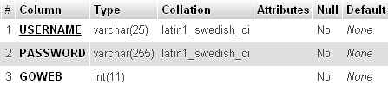
Figure 7. LOGIN Table
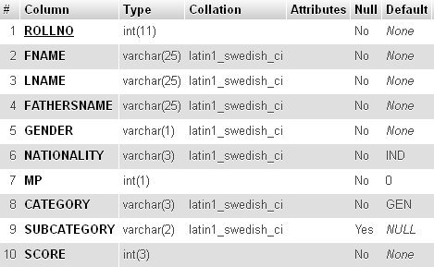
Figure 8. CET_STUDENT Table

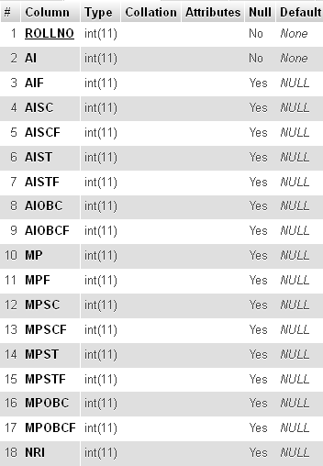
Figure 9. RANK Table
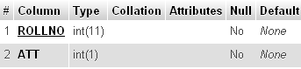
Figure 10. ATTENDANCE Table
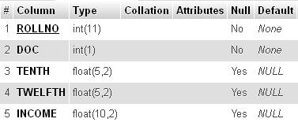
Figure 11. DOCUMENT Table
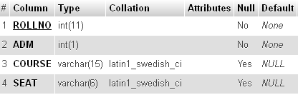
Figure 12. COURSE Table
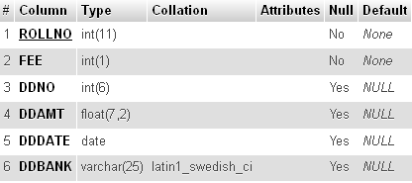
Figure 13. FEES Table
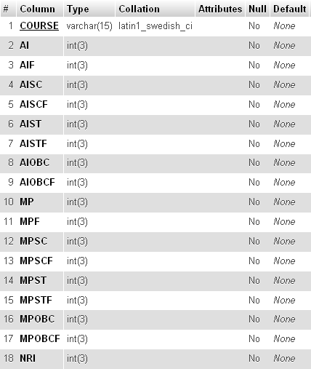
Figure 14. SEATS Table

INPUT OUTPUT DESIGN
For any system to work properly it is very necessary to keep a check over the input and output of the system. In this system, we have used relational database management system (MySQL) for storing and sending information. So, it imposes an additional constraint that the data inputted by the user should conform to the standards for insertion of data into database. For example, the 10th and 12th percentage attribute should only contain float numbers not characters and should not be greater than 100.

USER INTERFACE DESIGN
Any project how so ever good it may become failure if the end user, it is meant to cater cannot user it. For the end user to reap full benefits of the project, the project should have a good interface. Interface is the way a project links with the end user; it accepts the inputs from the user and gives output to the user. For a project, to be successful it should have a clean and understandable interface.

Properties of good interface are as follows:
- It should not be too bright in colors.
- The text written should be clear.
- Proper labeling should be done on labels and buttons.
- Proper warnings should be provided to the user at all levels.

TEST PLAN
Before implementing any system it is properly tested in order to verify that it conforms to its specifications and will meet the user requirements. The development of the software systems involves a series of production activities where opportunities for injection of human fallibilities are enormous. Errors may begin to occur at the very inception of the process where the objectives may be enormously or imperfectly specified, as well as in later design and development stages. Because of human inability to perform and communicate with perfection, software development accompanies quality assurance activity. Software testing is critical element of software quality assurance and represents the ultimate review of specification, design and coding.

Testing objectives are as follows:
- Testing is a process of executing or running a program with the intention of finding an error.
- A successful test is on that uncovers an as yet undiscovered error.
- A good test case is one that has a high probability of finding a yet undiscovered error.

The testing process usually commences with a test plan. Test plan is a general document for the entire project that defines the scope, approach to be taken and the schedule of testing as well as identifies the test items for the entire testing process and the personnel responsible for the different activities of testing. The test planning can be done in parallel with coding and design phases. It specifies the levels of testing and the units that need to be tested. For each of the different units first the test cases are specified and then they are reviewed. An important factor while forming a unit is the testability of a unit. A unit should be such that it can be easily tested, in other words it should be possible to form meaningful test cases and execute that unit without much effort with these test cases. During the test case execution phase, the test cases are executed, and various reports are produced for evaluating testing.

TEST CRITERIA
The approach for testing specifies the overall approach to be followed in the current project. Since the project is a dummy one, all the testing has been done with dummy data. Some of the testing conditions have been shown using screenshots. The testing has been done in two ways:
- Module Testing: Here the individual modules (web pages) were tested for errors. For example, as soon as the login page was designed it was parallel tested along side by side. Then when attendance page was designed it was parallel tested along side by side and so on.
- Comprehensive Testing: The various modules (web pages) were first integrated as single software and then testing is done for checking the discrepancies that may occur while the software is running.
SOFTWARE QUALITY ASSURANCE
- Adaptability: Since the counseling portal will be made with top priority that it should be easy to use and perform most of the complex jobs on its own. So, it will be easy to adapt as there will be nothing in this project that will confuse the user.
- Availability: This project will be totally based on web pages. So, if the server is connected to internet, then the project can be used from any part of the world using internet.
- Portability: The software will be portable as it works on web browsers. And web browser can work on many platforms whether it is Windows, Linux, Mac OS, etc.
- Reliability and Robustness: The software will be reliable as many facilities will be provided for checking the data redundancy, data integrity and data security, etc. This software will be robust as many error handling functions will be included in this software.
- Accuracy: Most of the data entries will be in form of checkbox, combo box and radio buttons. So in these cases, wrong data entry cannot happen. And in case of textboxes, they will be checked twice. Firstly, using JavaScript, then if by chance JavaScript cannot detect wrong data entry, then again data is checked by RDBMS.
- Maintainability and Testability: The software will be very easy to maintain. As in counseling, same procedure is to be followed for each and every student. And using few student data, the software can be tested for errors and the errors can be debugged.
SCREEN SHOTS

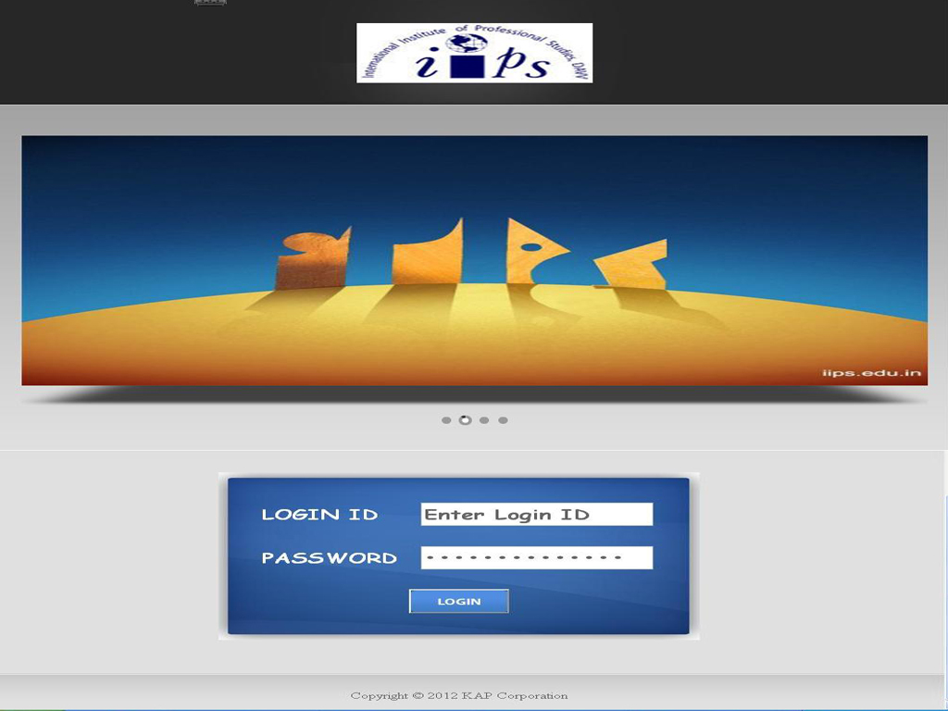
Figure 15. LOGIN Page
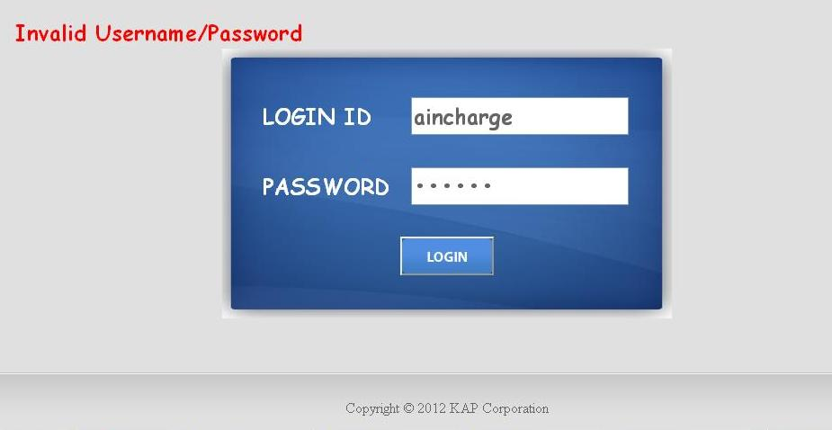
Figure 16. Login Page
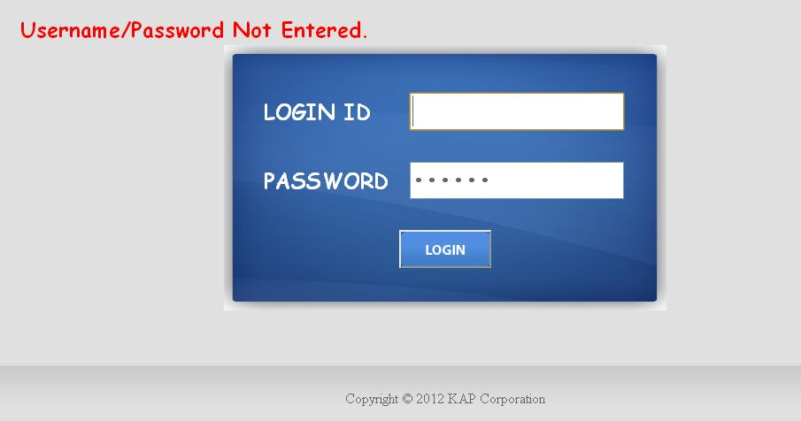
Figure 17. LOGIN Page
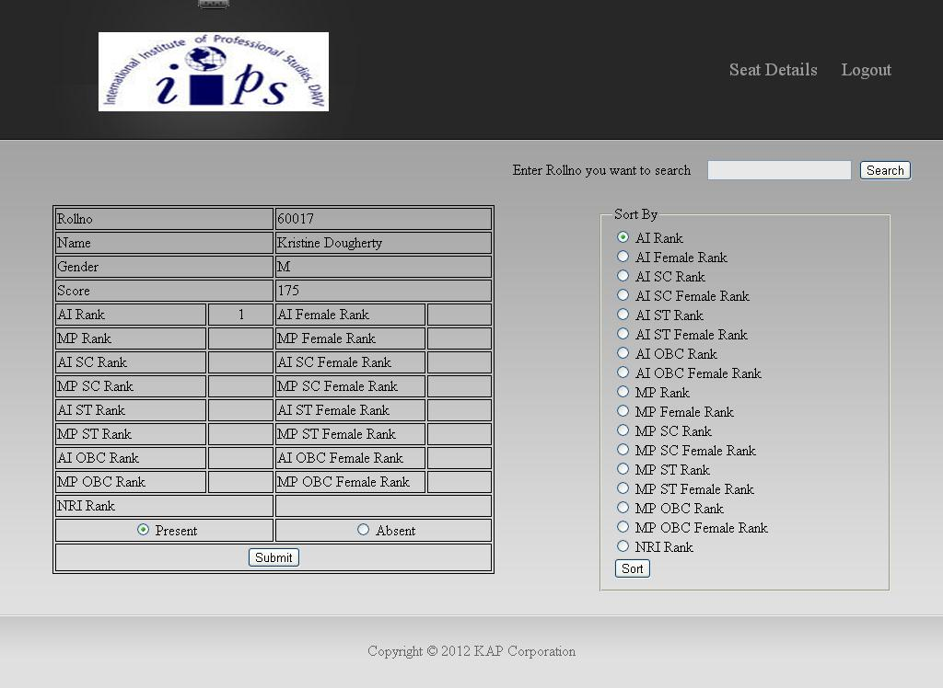
Figure 18. ATTENDANCE PAGE
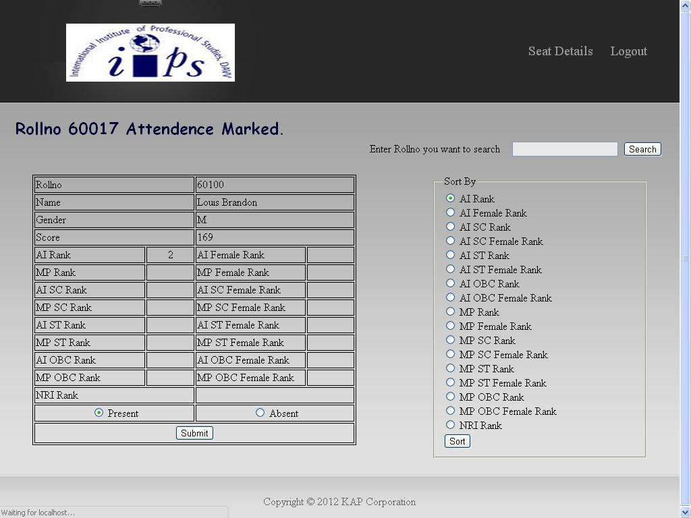
Figure 19. ATTENDANCE PAGE
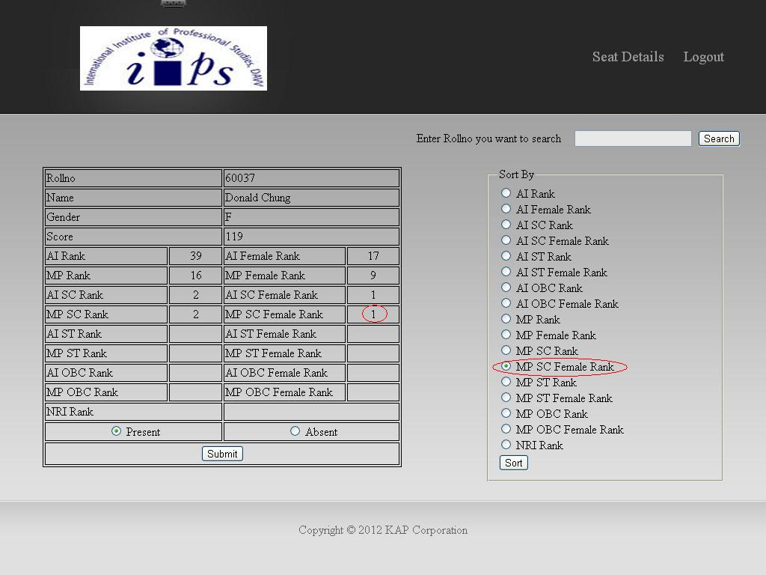
Figure 20. ATTENDANCE PAGE
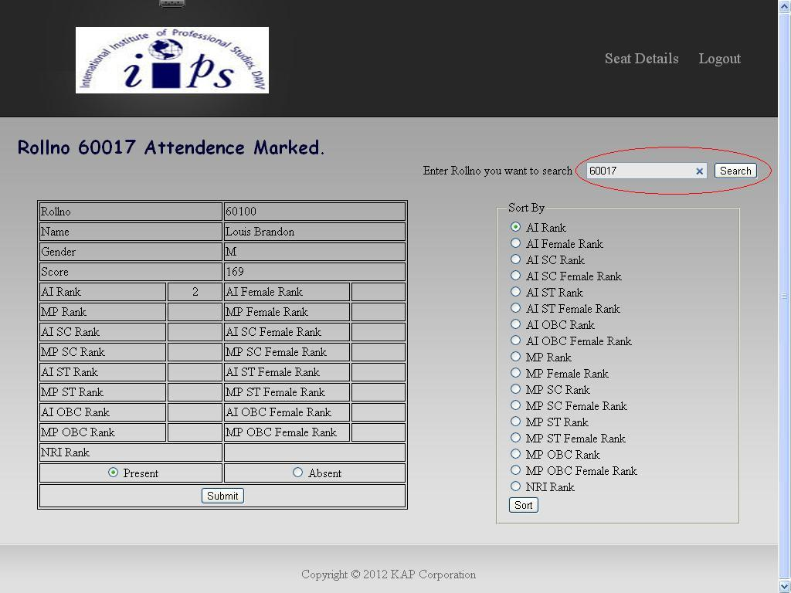
Figure 21. ATTENDANCE PAGE
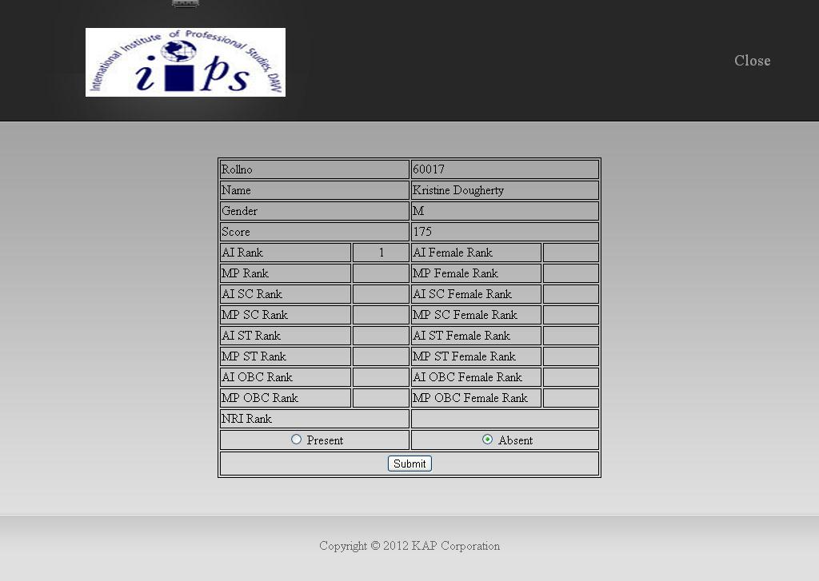
Figure 22. ATTENDANCE SEARCH PAGE
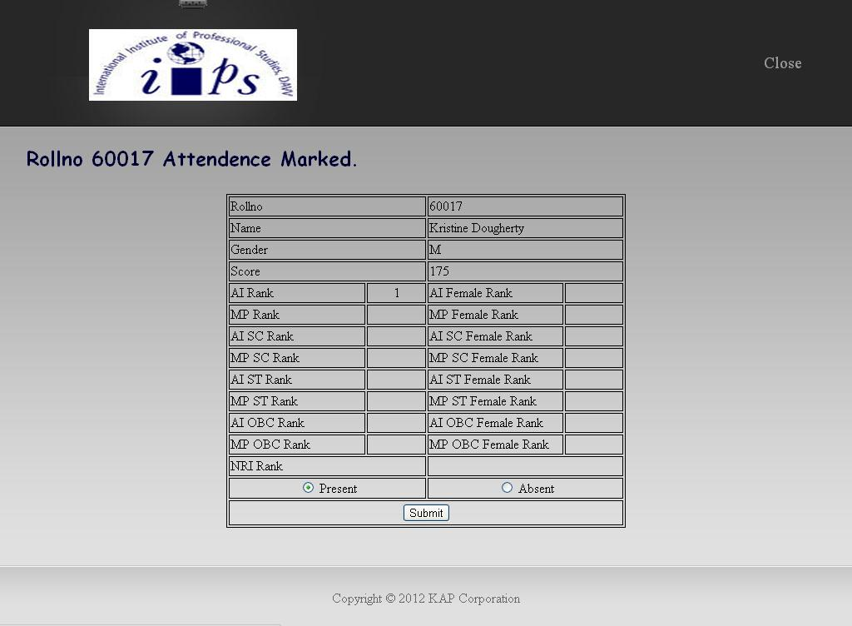
Figure 23. ATTENDANCE SEARCH PAGE

BOOKS AND MANUALS
- System Analysis And Design by Elias M. Awad
- Programming PHP by Rasmus Lerdorf and Kevin Tatroe
- Practical PHP Programming by Paul Hudson
- Learning MySQL by Sehed Tahaghoghi and Hugh Williams
- MySQL (4th Edition) by Paul DuBois

WEB RESOURCES
- www.google.com
- www.answers.yahoo.com
- www.w3schools.com
- www.stackoverflow.com
- www.go4expert.com

